Pune Institute of Computer Technology

Dhanakawadi, Pune-411043

Mini Project Report

On

**SaaS**

**Submitted By**

**Name: Manish Godbole**

Roll No. 31226 Class: TE 02

**Name: Kaustubh Joshi**

Roll No. 31233 Class: TE 02

**Name: Aditya Kadu**

Roll No. 31234 Class: TE 02

Under the guidance of

**Prof. M. R. Jansari**

DEPARTMENT OF COMPUTER ENGINEERING

Academic Year 2023-2024

**CERTIFICATE**

This is to certify that the Mini Project Report entitled  
“SaaS”

has been successfully completed by

**Manish Manoj Godbole(31226)**

**Kaustubh Narendra Joshi (31233)**

**Aditya Shankar Kadu (31234)**

Is a bona fide work carried out by them under the supervision of Prof. M. R. Jansari and it is approved for the partial fulfillment of the requirements for the Lab Practice-II subject of T.E. Computer Engineering – 2019 course of the Savitribai Phule Pune University, Pune.

Prof M. R. Jansari Prof. Geetanjali Kale

Project Guide HOD, Computer Engineering

Dept. of Computer Engineering

Place: Pune

Date: 18/04/2024

s

**ACKNOWLEDGEMENT**

We are fortunate to have received this support during the completion of our project because the success and conclusion of our project required a lot of direction and assistance from many individuals. We would want to use this opportunity to express our gratitude for the guidance and support in everything we have accomplished. We over debt of appreciation to Prof. M. R. Jansari, our project advisor, who showed a genuine interest in us and helped us through the entire process of giving us all the information we needed. A special thank you to Prof. Geetanjali Kale, our HOD.

**CONTENTS**

1. **TITLE**
2. **PROBLEM DEFINITION**
3. **LEARNING OBJECTIVES**
4. **LEARNING OUTCOMES**
5. **ABSTRACT**
6. **MODULES**
7. **ER DIAGRAM**
8. **OUTPUT SCREENSHOTS**
9. **TEST CASES**
10. **CONCLUSION**

# Title: Building a Secure Self-Hosted Cloud Infrastructure: Implementation and Encryption Strategies with HDFS

**Problem Definition:**

Setup your own cloud for Software as a Service (SaaS) over existing LAN in your laboratory. In this assignment you have to write your own code for cloud controller using open source technologies to implement with HDFS. Implement the basic operations may be like to divide file in segments/ blocks and upload/download file on/ from cloud in encrypted form.

**Learning Objectives:**

1. To develop a comprehensive understanding of cloud computing principles and architectures, focusing on the deployment of Software as a Service (SaaS) over a local area network (LAN).
2. To explore open-source technologies for building a cloud controller, with an emphasis on implementing functionalities such as file segmentation, block storage, and encryption using Hadoop Distributed File System (HDFS).
3. To gain practical experience in designing and coding custom solutions for cloud management, including the development of algorithms for dividing files into segments or blocks suitable for distributed storage.
4. To investigate encryption techniques and security measures for safeguarding data integrity and confidentiality within a self-hosted cloud environment, particularly during file upload and download processes.
5. To demonstrate proficiency in implementing basic cloud operations, including uploading and downloading files, while ensuring that data remains encrypted both at rest and in transit, thus adhering to best practices in cloud security.

**Learning Outcomes:**

1. Proficiency in Cloud Infrastructure
2. Mastery of Cloud Controller Development
3. Understanding of Distributed File Systems
4. Competence in Encryption Techniques
5. Application of Cloud Security Principles

**Abstract:**

This study focuses on the development and implementation of a secure self-hosted cloud infrastructure for Software as a Service (SaaS) deployment over a local area network (LAN). The assignment involves writing custom code for a cloud controller using open-source technologies, with a specific emphasis on integrating functionalities such as file segmentation, block storage, and encryption using the Hadoop Distributed File System (HDFS). Through this project, students will achieve a comprehensive understanding of cloud computing principles and architectures, with practical experience in designing and coding custom solutions for cloud management.

The primary objective of the assignment is to equip students with the necessary skills to design and deploy a self-hosted cloud infrastructure. By leveraging existing LAN resources and open-source technologies, students will learn to optimize resource utilization and enhance the scalability of their cloud environment. Additionally, students will develop proficiency in developing a custom cloud controller capable of managing basic operations such as file segmentation, block storage, and encryption using HDFS.

A key focus of the assignment is on distributed file systems, particularly the Hadoop Distributed File System (HDFS), and its role in facilitating efficient storage and retrieval of large-scale data in a distributed environment. Students will gain a deep understanding of HDFS architecture and its integration within the broader context of cloud computing.

Furthermore, students will explore encryption techniques and security measures essential for safeguarding data integrity and confidentiality within the cloud infrastructure. By implementing encryption mechanisms for file upload and download processes, students will demonstrate competency in encryption techniques and apply fundamental principles of cloud security.

In summary, this project offers students a hands-on learning experience in cloud infrastructure development, encompassing cloud controller development, distributed file systems, encryption techniques, and cloud security principles. Through practical implementation and experimentation, students will acquire valuable skills and knowledge essential for building and managing secure cloud environments.

**Modules:**

1. **Cloud Controller Development**: This module focuses on developing the core functionality of the cloud controller using open-source technologies. It involves writing code to manage file segmentation, block storage, encryption, and other essential operations for cloud management.

2. **File Segmentation Algorithm**: Within this module, students will design and implement algorithms to divide files into segments or blocks suitable for distributed storage. This includes considering factors such as file size, storage capacity, and data redundancy.

3. **HDFS Integration:** In this module, students will integrate the developed cloud controller with the Hadoop Distributed File System (HDFS). They will learn to utilize HDFS APIs and libraries to interact with the distributed file system for storing and retrieving segmented files.

4. **Encryption Mechanisms**: This module focuses on implementing encryption techniques to ensure data security during file upload and download processes. Students will explore encryption algorithms, key management, and data protection mechanisms to safeguard sensitive information.

5. **File Upload and Download Operations**: Students will develop functionalities for uploading files to the cloud infrastructure and downloading them securely. This involves implementing protocols for data transfer, authentication mechanisms, and error handling to ensure reliable file transfer operations.

6. **Testing and Validation**: Throughout the project, students will conduct testing and validation to ensure the correctness and robustness of the implemented functionalities. This includes unit testing, integration testing, and validation against use cases to verify the performance and security of the cloud infrastructure.

7. **Documentation and Reporting**: Finally, students will document their project implementation, including design decisions, code documentation, and user manuals. They will prepare a comprehensive report summarizing the project objectives, methodologies, results, and lessons learned during the development process.

**Database Schema:**

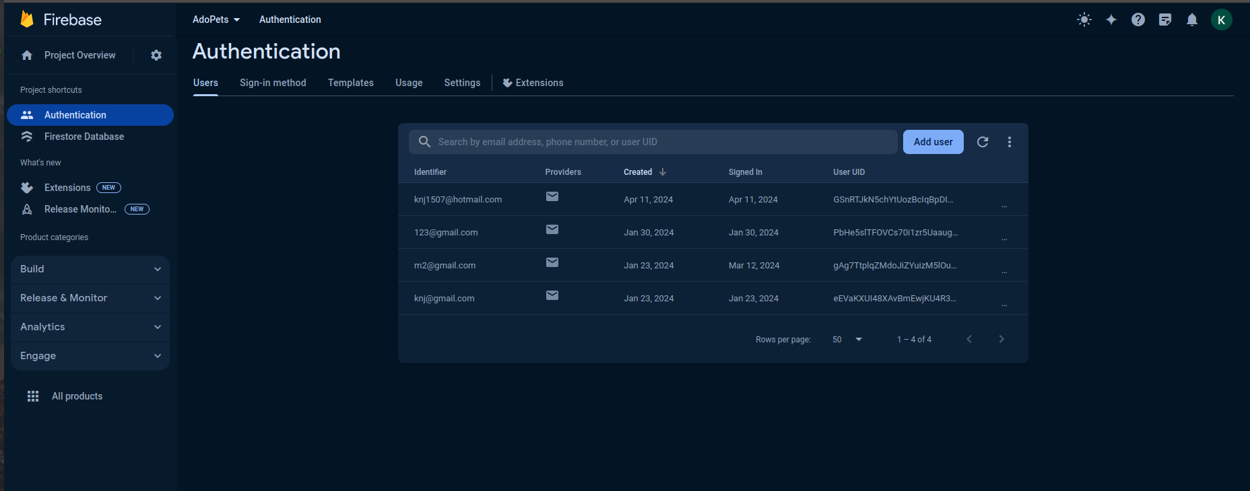

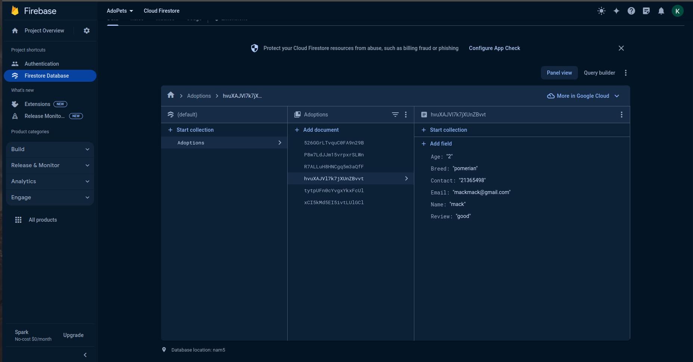

**Output Screenshots:**



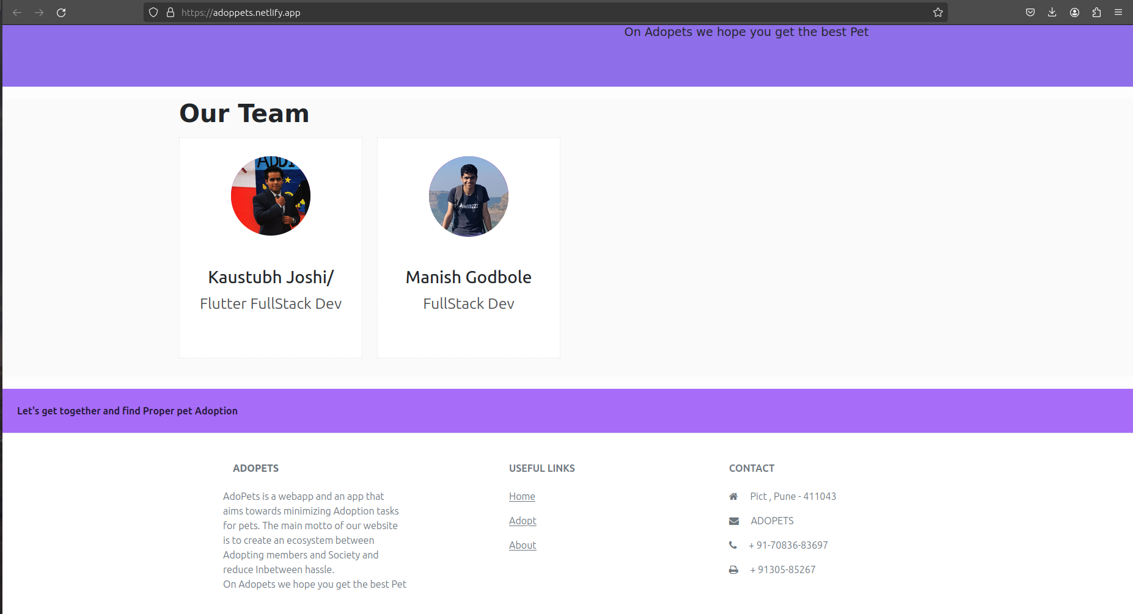

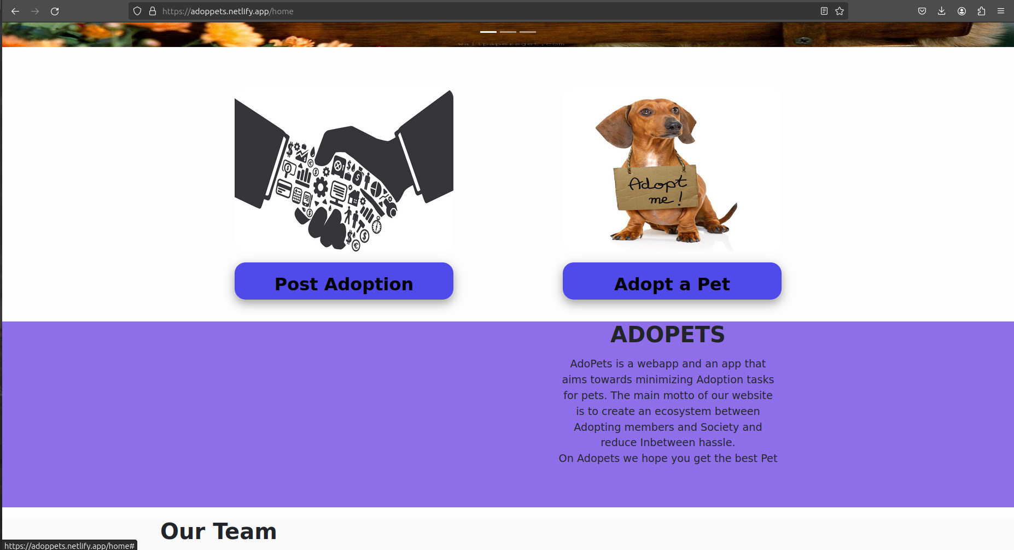

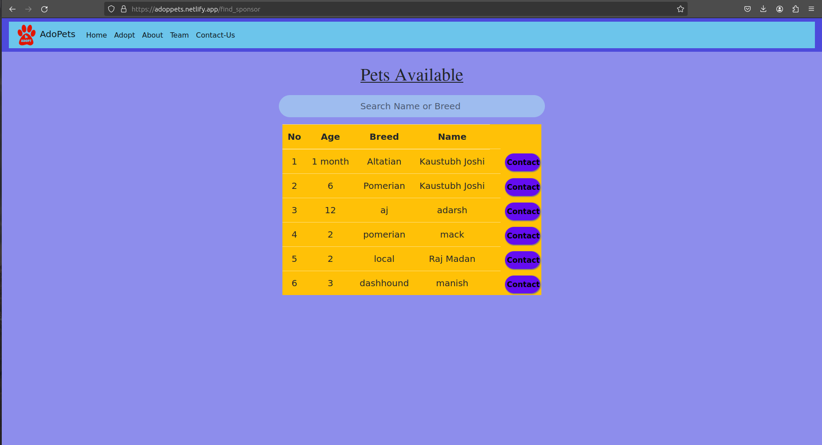

**TEST CASES:**

1. Adoption





1. Add a Pet

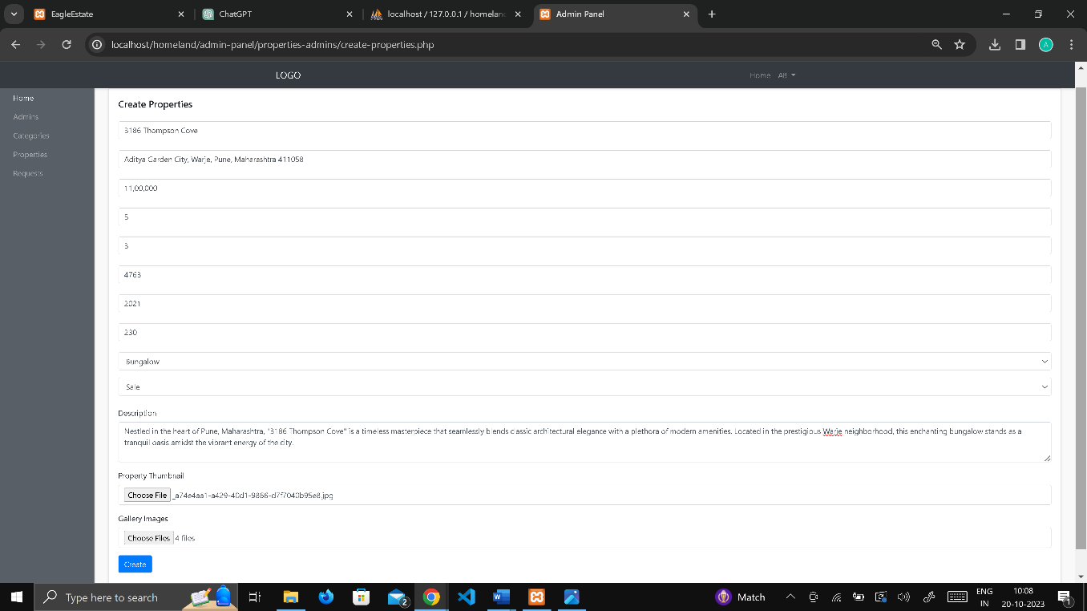

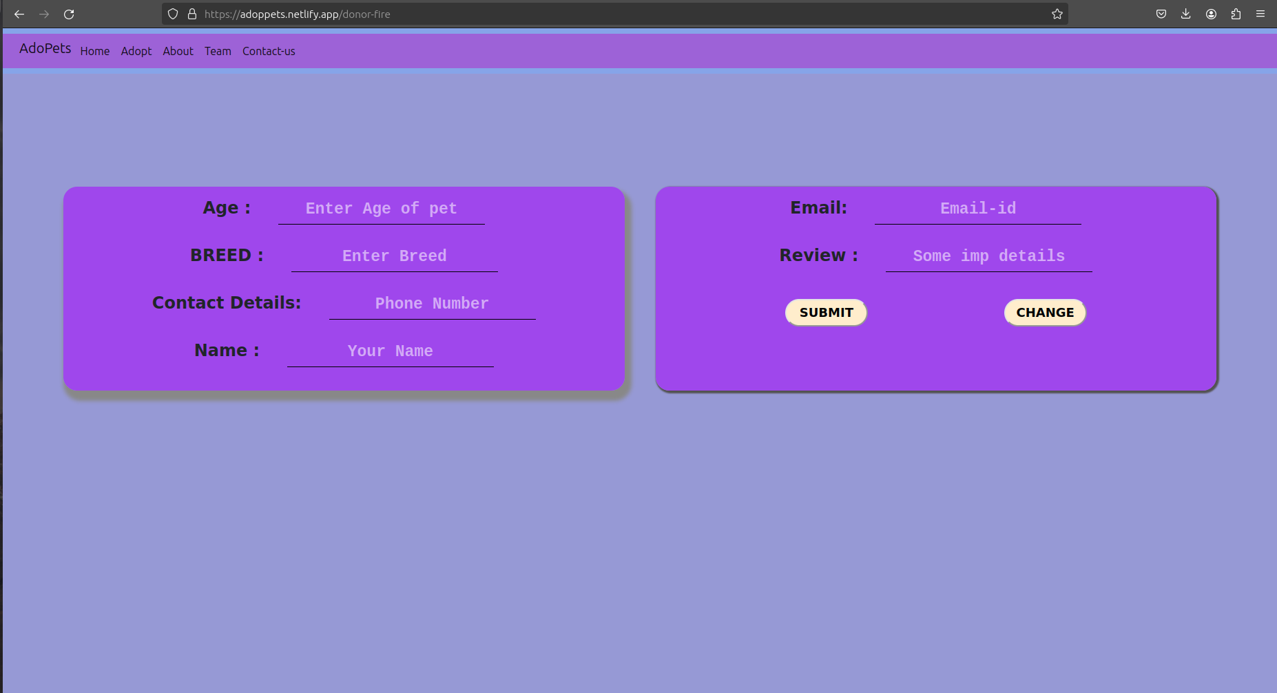

1. Contact Us

**CONCLUSION:**

In conclusion, the project presents an opportunity for students to gain hands-on experience in developing a secure self-hosted cloud infrastructure using open-source technologies. Through implementing custom code for cloud controllers, integrating with Hadoop Distributed File System (HDFS), and incorporating encryption mechanisms, students can acquire valuable skills essential for building and managing robust cloud environments.